Hover email signature.

Please see Google instructions [here](https://support.google.com/mail/answer/8395?hl=en&co=GENIE.Platform%3DDesktop#zippy=%2Cedit-signatures%2Cremove-signatures) for how to add a signature.

Each email platform, like Gmail or Apple Mail, operates differently. They use different fonts, colors, and systems to display emails, and each handles images in its own way. This makes it hard to control a consistent signature across all platforms in different modes (light or dark). Because of these constraints, we are using a simple type-based signature for our emails.

Example signature 01:

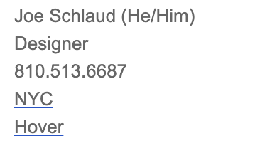

Example signature 02:

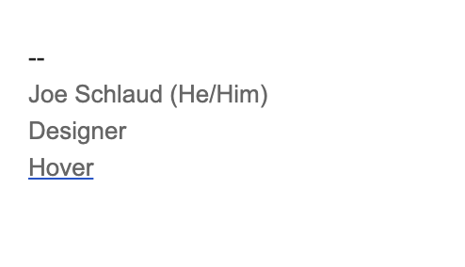

Required

1. Name
2. Role

Optional

1. Pronoun
2. Phone number
3. Office hub